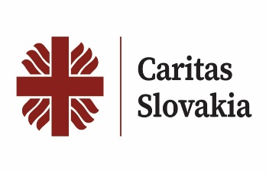
Partner for Responsible Circular Economy and Social Solidarity

Who We Are
Caritas Slovakia is the largest church-based charitable organization in Slovakia with over 95 years of tradition. We are part of the European Caritas network - Caritas Europe and the global Caritas Internationalis network. We operate through 11 diocesan and archdiocesan charities and hundreds of local branches across Slovakia. Our work combines social assistance, sustainability, and solidarity — we stay close to people, help those in need, fight poverty and contribute to environmental protection.

What We Do in Collection and Recycling
- Clothing and textile collection – we operate charity containers and organize collections; part of the clothing goes directly to people in need, and part is processed in partner sorting centers.
- Furniture and household items collection – donated furniture and appliances get a second life with families in social need, refugees or clients of crisis centers.
- Waste recycling and sorting – we cooperate with cities, municipalities, and companies to reduce waste, reuse materials, and implement circular solutions.
- Social dimension – we connect environmental goals with support for people who cannot meet their basic needs on their own.

Why to be a Partner with Caritas Slovakia
- Network and trust – nationwide coverage and a trusted brand
- Social and ecological impact – waste reduction goes hand in hand with tangible help for families, seniors, and children
- Stakeholder partnerships – cities, municipalities, schools, companies, and recycling firms can link their CSR activities with real impact through Caritas Slovakia
- Innovation in circular economy – we seek modern solutions for sorting, recycling, and reusing materials

Our Needs and Partnership Offers
- Expansion of the network of collection containers and collection points
- Project partnerships in textile and furniture processing and recycling
- Joint projects in CSR, ESG, and circular economy
- Logistical and technological cooperation in waste sorting
- Joint campaigns and public awareness initiatives

Contact
Caritas Slovakia
Kapitulská 18, 814 15 Bratislava
Slovakia
📧 sekretariat@charita.sk
📧 mihalova@charita.sk
🌐 www.charita.sk

